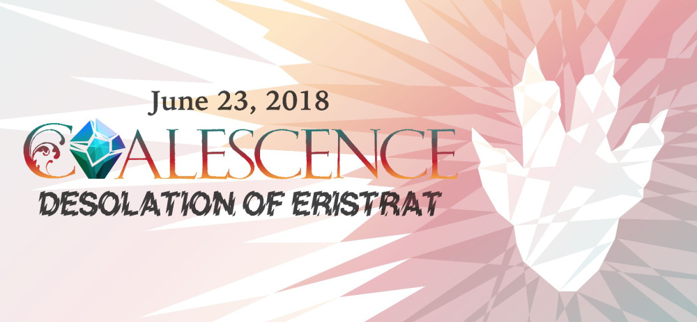
EVENT PACK

Welcome, NEO!
In this pack we are providing the essentials for the day of the event (JUNE 23), but it’s YOUR event. Run it how you’d like, embellish it with more ideas, or strip it down. Whatever suits your comfort level and environment. But this also means that it’s up to you to find the venue, charge fees or not, register players, setup the tables and terrain, and provide awards. Check out the blog on WeAreTheNEON.com for helpful articles written by experienced organizers, or reach out to the network by emailing WeAreTheNEON@gmail.com

From here on out, when this packet says NEO, it means you! Welcome to the Narrative Event Organizer Network (NEON).

WHAT KIND OF EVENT IS THIS?
This is an introductory narrative event that should be simple enough for new event organizers to feel comfortable running, while providing some fun new narrative ideas for you veteran storytellers. Think of it as a mini campaign that gets completed in a day and provides enough substance for your players to walk away with great stories of triumph and ruin.

SYNOPSIS
In the wake of Eristrat’s release, Archaon seized control of it. Now the players in the mortal realms are acting to either empower the godbeast or banish it.

WHAT, WHERE, WHEN?
What: 1 day, 3 Games, Age of Sigmar
Where: NEO’s choice
When: Saturday, June 23rd, 2018

3 LINKED GAMES OF VARIED SIZES
Players should bring 1250 points of models that can also be broken down into 1250, 1000 and 750 point lists, as well as a 60-Renown Skirmish list. You can include Rules of 1 and Reinforcement Rules per the GHB. We recommend that the pitched battle Vanguard limitations for construction be ignored with the exception of 200 points for allies, but the battleplans will be fully playable with normal Vanguard construction. The one ‘MUST HAVE’ is a model with the Hero keyword that will be the general through every game.

TWO OPPOSING TEAMS
Players will be playing in teams representing two opposing factions. One side aims to EMPOWER the godbeast Eristrat while the other side tries to BANISH the threat to the Mortal Realms. Let your players join whichever side they prefer, regardless of Grand Alliance. But you work with your players to decide what’s best for YOUR event.

TEAM OBJECTIVES
In the story, each general is attempting to accomplish feats which will empower Eristrat and make him a more powerful weapon or banish Eristrat and put an end to the desolation the godbeast is leaving across the mortal realms. While the battleplans have objectives that advance the story, winning a Major Victory in the scenario is just one of 7 feats that players can accomplish to further the agenda of their respective team. But only one team member needs to accomplish any given objective to score it for the team. The team that scores the most feats determines the battleplan for the next round.

TREE STRUCTURE
The event is based on a tree-structure campaign, and the result of each round will determine which battleplan is used for the next. There are a total of seven battleplans in this pack, but only three of those will be used in each event! So your event may feature different battleplans from other events.

FEATS & VICTORY
This is an event focused on scoring feats by team, so achieving the victory conditions in games isn’t the only way teams score and “win” each round. It only takes one player on a team to complete an achievement in order to score it for the team. Good teamwork and communication about which feats different players should strive for can be key to ultimate victory.

Throughout the battles, players will also accumulate a number of Realmstone Shards. These shards would be an important key to the goals of the armies of the Mortal Realms, and they will be used for several decisions throughout the games. In the third game, the Realmstone total will help determine the General for the combined teams of players. We also recommend that the Realmstone total for the Empower and Banish teams be used to determine the victor in the case of a tie.

AGE OF SIGMAR: SKIRMISH
The first game of the Desolation of Eristrat event uses the rules found in Ageof Sigmar: Skirmish. In addition to the rules and Renown values found in this book, NEOs may wish to refer players to the following sources:

- Skirmish Official Errata, April 2018
https://www.warhammer-community.com/faqs/
- TGA.Community Forum Skirmish Expansion
http://www.tga.community/forums/topic/9851-age-of-sigmar-skirmish-full-points-list/
REPORTING YOUR NARRATIVE
The team with the highest score of feats at the end of your event will help determine whether Eristrat is EMPOWERED or BANISHED. This is the only info you will need to report to affect the global story.
To report the result for your event:

- Snap a photo of all your players together holding up EMPOWER WINS or BANISH WINS. Use the included sheets at the end of this pack if you wish.
- Post it to Twitter or to the AoS NEON group on Facebook, or email to wearetheneon@gmail.com
- Use the hashtag #CGNE18
- Include the location of your event, both city and country!

Results will be tallied from all events reporting and a global result posted online!

CLOSING CEREMONIES & REWARDING PLAYERS
Once all the games have been played, and you’ve reported your narrative outcome, it’s time to thank your players. In addition to the memories, some events may provide rewards. This may range from printed certificates to a box of miniatures or gift certificates (your local game store may be willing to provide prize support). A recommendation for narrative play events is to bestow titles on players who performed a particular feat the most. For instance, one of the objectives is to have a HERO without the MONSTER keyword, slay a model with the MONSTER keyword. The player who does this the most gains the title of Monster Slayer for the event. You could also pick a place for everyone to go out for dinner and recap the cool stories of the day. Whatever you decide, make sure the players feel like today was a bit more special than their regular games of Age of Sigmar.

A team “wins” each round by scoring the most feats as a team. In the case of a tie, use total number of realmstone shards. Remember: each team can only score a feat once per team, regardless of how many individual players may have scored.

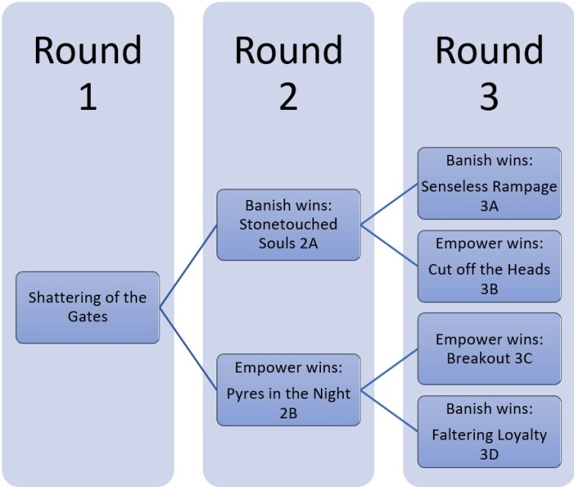

COALESCENCE 2018 BATTLEPLAN 1:
THE SHATTERING OF THE GATES

In the wake of Eristrat’s assaults many realmgates lie broken. Archaon has used the might of the beast to deny Sigmar his captured realmgates, undoing decades of fighting and countless sacrifices. What the Everchosen’s ultimate goal is, none know. Yet from the fragments of the realmgates shards of Realmstone have awakened. These ruined stones glow with baleful energies, many of their potent magics yet remaining. The lords of the realms have decreed that realmstone must be gathered. Across the Mortal Realms, countless warbands surge towards the devastation, seeking honour and glory and shards that resonate with the very realm itself. Only through these powers can Eristrat be empowered or banished.

THE WARBANDS
One player belongs to the Empower faction, and the other belongs to the Banish faction. Both sides seek to gather as much baleful realmstone as possible. The players choose their warbands as described in the Warhammer Age of Sigmar: Skirmish book. If used as part of Coalescence: Desolation of Eristrat event, each warband cannot consist of more than 60 renown.

THE BATTLEFIELD
Place a terrain piece in the center of the board. This is the ruins of the baleful realmgate (you can use a regular realmgate to represent it, but any terrain piece will do). Do not roll for Mysterious Landscapes for this terrain piece. Instead this broken realmgate uses the Magical Energies rule from the Baleful Realmgate warscroll (but not the other rules). Generate the remaining terrain as per the Skirmish rules or in a manner most fitting the story being told.

SET-UP
Before choosing sides, each player must place 3 Baleful Realmstone tokens. Both players roll a dice, and the player who rolls higher places the first token. Token placement then alternates between the players until all tokens are placed. When placing each token, roll 4D6, you may place the token anywhere within that range from the center of the board, as long as it also more than 6” from the center of the board and 6” from other pieces of Baleful Realmstone. If a piece cannot be placed within those restrictions, move it the minimum distance necessary to do so.
Players then roll a dice, the player who rolled the highest (reroll in case of ties) may deploy a unit first. Players then alternate deploying models. Models must be deployed more than 6” from Baleful Realmstone tokens and more than 9” from enemy models.

BALEFUL REALMSTONE
Baleful Realmstone are shards of Realmstone that were once used to build realmgates. Though Eristrat destroyed the gates, their powerful magics are still bound to the stone itself. Though it is even less stable than it once was...

To pick up a piece of Baleful Realmstone, a model must end its movement touching a Baleful Realmstone token. This piece of Baleful Realmstone is now considered to be carried by this model. Models may carry more than one piece of Baleful Realmstone. Pieces of Baleful Realmstone are carried by the model until the model is destroyed, at which time any Baleful Realmstone tokens are returned to the battlefield in the space once occupied by the model. Models may also drop the Baleful Realmstone token at the end of the turn. Place the Baleful Realmstone token touching the model.

HAZARDOUS JOURNEY
In your movement phase, any friendly unit carrying Baleful Realmstone may attempt to make a hazardous journey. If you wish to do so, roll a dice, on a 2 or more, you may remove the unit from the battlefield and set it up within 1” of any other unclaimed piece of Baleful Realmstone or within 3” of the ruins of the Baleful Realmgate. If you roll less than 2, the unit is destroyed.

You may also attempt to move to a claimed piece of Baleful Realmstone. However, your enemy will use its magic to resist you, and the dangers increase! Subtract 1 from the roll to see if the unit is lost. If successful, set up the unit within 1” of an enemy model carrying Baleful Realmstone.

VICTORY
Do not use any victory conditions from the Warhammer Age of Sigmar rules sheet. The game lasts five battlerounds.
The player with the most pieces of Baleful Realmstone at the end of the fifth battleround wins a major victory, and the player that held the least pieces received a major loss. If neither player holds a piece of Baleful Realmstone at the end of the fifth battleround, then both players receive a minor loss.

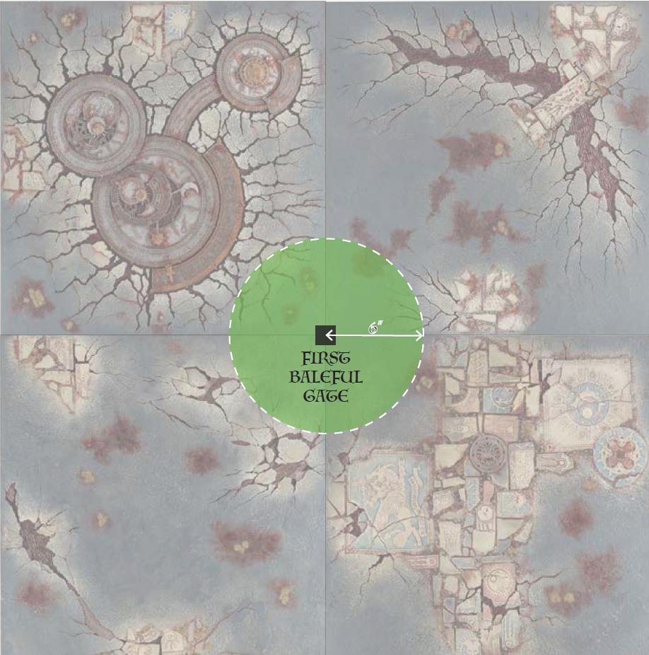

COALESCENCE 2018 BATTLEPLAN 1:
THE SHATTERING OF THE GATES
Player Scoresheet
Feat | Value | You or a member of your alliance | Achieved?
Strategist | 3 | Win the battleplan
Monster Hunter | 1 | ...had a HERO without the MONSTER keyword that slayed a MONSTER
Royal Terror | 1 | ...destroyed an opponent’s unit in the Battleshock phase.
Stronger Together | 1 | ...had a BATTLELINE unit that killed a HERO.
Still only counts as one | 1 | ...destroyed an enemy unit within 3” of the attacker in the shooting phase.
WAAAAGH! | 1 | DESTRUCTION ONLY: Complete a charge in the first battleround
Long Reach of Death | 1 | DEATH ONLY: Set up a unit in your opponents deployment zone
All for One | 1 | ORDER ONLY: Do not lose any units to battleshock
Favor of the gods | 1 | CHAOS ONLY: Slay an enemy HERO with a HERO
Bravery | 1 | Use Hazardous Journey to set up models.
True Bravery | 1 | Use Hazardous Journey to set up models within 1” of an enemy model.
Hoarder | 1 | Have a single model carry 3 or more pieces of Baleful Realmstone at once.
Grand Theft Lapis | 1 | Take a Baleful Realmstone piece by slaying the enemy unit carrying it.

Coalescence: Desolation of Eristrat Realmstone Shards
Each piece of Baleful Realmstone also counts as a piece of Realmstone Shard for the purpose of Coalescence: Desolation of Eristrat event rules.
Number of Realmstone Shards

COALESCENCE 2018 BATTLEPLAN 2A:
STONETOUCHED SOULS

The defenders of these lands were successful in gathering the remains of the shattered realmgate. They are now cut off from the rest of the Realms, but filled with new hope. This power may hold the key to banishing Eristrat from this realm and discovering a means to defeating the godbeast forever.

But those brave souls that recovered the realmstone find themselves glowing with an elemental light, and feel their soul slowly being consumed. If this power is not purified and returned to the Realm, then your staunchest defenders may perish and the land may be left weaker still!

Use this battleplan if the Banish team has won the first round of battles with the most feats scored.

The armies
One player belongs to the Empower faction, and the other belongs to the Banish faction. If using this battleplan as part of the Coalescence: Desolation of Eristrat event, each player may select an army of up to 1000 points (but do not need to follow the other Matched Play restrictions).

The battlefield
This battleplan is fought across a 4’x4’ battlefield. Set up terrain as fits your realm, or as instructed in the Age of Sigmar rules sheet.

Time of War: Desolation of Eristrat
This battleplan uses the Time of War: Desolation of Eristrat rules to describe how models may interact with Realmstone Shards. This battleplan may be played using additional Time of War rules along with Desolation of Eristrat.

Set-Up
Before deploying, place 4 markers on the battlefield as shown on the map. These are the Places of Power.
In addition, after deployment and before the first turn, each player nominates 3 units to be the Stonetouched. Only one of these may be a Hero or Monster.

The Stonetouched
There is power in being bonded by bone and blood. But such power comes at a terrible cost, too much for most to bear.
Any unit that is Stonetouched may re-roll 1’s for Charge and Hit rolls. At the end of each of the controlling players hero phase, roll a dice for each unit of Stonetouched. On a 4 or more, the unit suffers D3 Mortal Wounds.

Places of Power
Stonetouched units may use a Place of Power to purify their souls after the effects of the realmstone. If a Stonetouched unit ends their Hero phase wholly within 6” of a Place of Power, it is Partially Purified. If a Stonetouched unit ends a Hero Phase wholly within a second Place of Power, it is Fully Purified and no longer affected by the Stonetouched rule. Only a single unit may be purified on each site during each turn. Purified units still count as Stonetouched for the purpose of Victory Conditions.

Victory
Do not use any victory conditions from the Warhammer Age of Sigmar rules sheet. The game lasts five battlerounds.

Each unpurified Banish Stonetouched unit is worth a single point, a Partially purified unit is two points, and a Wholly Purified unit worth three points. The Banish player scores for each unit that survives until the end of the game, with points awarded according to its status.

The Empower player scores the number of points the Stonetouched unit was worth when they destroyed the unit.

The player with the highest point total wins a major victory.

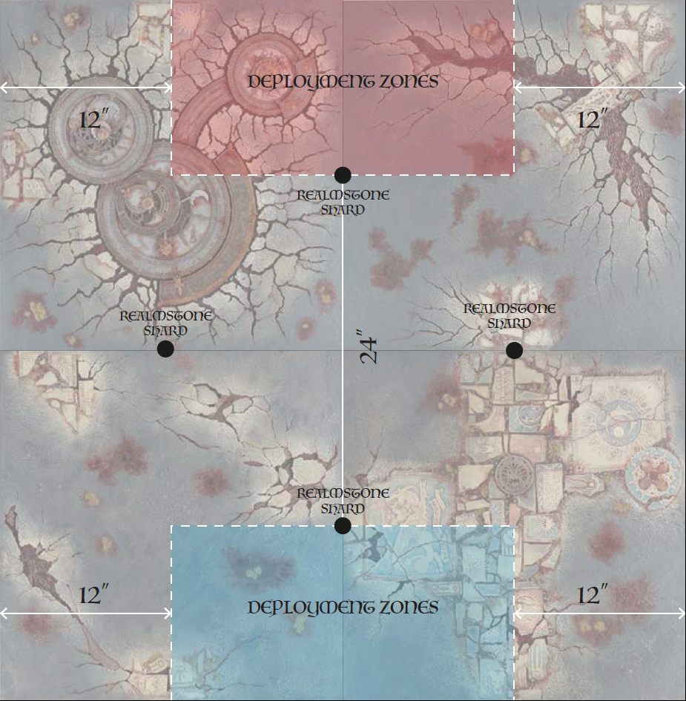

COALESCENCE 2018 BATTLEPLAN 2A:
STONETOUCHED SOULS
Player Scoresheet
Feat | Value | You or a member of your alliance | Achieved?
Strategist | 3 | Win the battleplan
Monster Hunter | 1 | ...had a HERO without the MONSTER keyword that slayed a MONSTER
Royal Terror | 1 | ...destroyed an opponent’s unit in the Battleshock phase.
Stronger Together | 1 | ...had a BATTLELINE unit that killed a HERO.
Still only counts as one | 1 | ...destroyed an enemy unit within 3” of the attacker in the shooting phase.
WAAAAGH! | 1 | DESTRUCTION ONLY: Complete a charge in the first battleround
Long Reach of Death | 1 | DEATH ONLY: Set up a unit in your opponents deployment zone
All for One | 1 | ORDER ONLY: Do not lose any units to battleshock
Favor of the gods | 1 | CHAOS ONLY: Slay an enemy HERO with a HERO
The Rock (Banish) | 1 | A Stonetouched unit destroyed an enemy unit.
You’ve got the Power (Banish) | 1 | Have a unit within 3” of each place of power at the same time.
Get this thing out of me! (Empower) | 1 | Purify a unit of Stonetouched.
Might as well use it… (Empower) | 1 | Successfully charge with all 3 Stonetouched units in the same phase.

Coalescence: Desolation of Eristrat Realmstone Shards
Each point of Banish Stonetouched units also counts as a piece of Realmstone Shard for the purpose of Coalescence: Desolation of Eristrat event rules.
Number of Realmstone Shards

COALESCENCE 2018 BATTLEPLAN 2B:
PYRES IN THE NIGHT
Archaon’s will be done! In Eristrat’s wake, your forces were ready to pounce on the broken defenders. Now you have the prize, stones burning with the elemental power of the realms themselves. The godbeast’s assault cut off your route to Eight Points, but in this site, the power can be spirited back to your master and the Eristrat itself. The souls of those that touched the stone are all that are needed to ensure a safe voyage. Small price to pay!

Use this battleplan if the Empower team won the first round of battles with the most feats scored for the team.

The armies
One player belongs to the Empower faction, and the other belongs to the Banish faction. The Empower player should have a slightly larger force than the Banish faction.

If played as part of the Coalescence: Desolation of Eristrat event, the Empower player should have 1250 points and the Banish players should have 1000 points, ignoring any other restrictions from Matched Play rules.

The battlefield
This battleplan is fought across a 4’x4’ battlefield. Set up the battlefield as best suits your story, or as per the Age of Sigmar rules sheet.

Time of War: Desolation of Eristrat
This battleplan uses the Time of War: Desolation of Eristrat rules to describe how models may interact with Realmstone Shards. This battleplan may be played using additional Time of War rules along with Desolation of Eristrat.

Set-Up
Place 3 markers in the Empower player’s territory as shown on the map. These are the Sacrifice Sites.
The Empower player must set up a unit within 6” of each of these Sacrifice Sites. These are the Stonetouched units.

The Sacrifice
To gain power from the Stonetouched, some sacrifices must be made.

In each of the Empower player’s hero phases, you may choose to sacrifice up to 3 models from a Stonetouched unit to each Sacrifice Site. The Stonetouched unit must be wholly within 6” of the site. If you do so, remove the models from the board. You then roll a dice for each site that was sacrificed to, adding 1 to the roll for each Wound worth of models sacrificed (for instance, if you sacrifice a single Bloodreaver, add 1, a Blood Warrior, add 2, a Wrathmonger add 3, etc). On a roll of 6 or more, the Sacrifice Site adds 1 to its value. The starting value of all Sacrifice Sites is zero. You may only sacrifice to each site once per Empower hero phase.

Commanding the site
When the fire burns away flesh, you don’t want to stick your hand in to pick up a rock. Better wait a bit.

The player who has the most models within 6” of a Sacrifice Site controls the site.

Victory
Do not use any victory conditions from the Warhammer Age of Sigmar rules sheet. The game lasts 5 turns.

At the end of the last battleround, count the points value of the Sacrifice Sites under each players control. The player with the highest total value wins a major victory. If neither player achieves a points value of greater than zero, than both players suffer a minor loss.
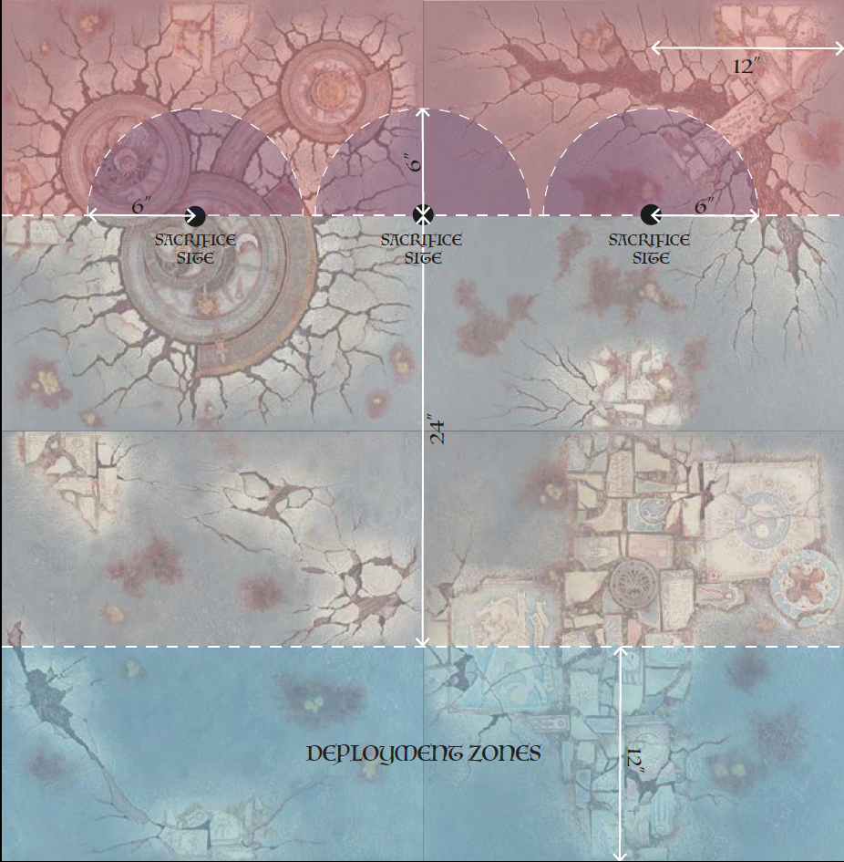

COALESCENCE 2018 BATTLEPLAN 2B:
PYRES IN THE NIGHT
Player Scoresheet

Feat | Value | You or a member of your alliance | Achieved?
Strategist | 3 | Win the battleplan
Monster Hunter | 1 | ...had a HERO without the MONSTER keyword that slayed a MONSTER
Royal Terror | 1 | ...destroyed an opponent’s unit in the Battleshock phase.
Stronger Together | 1 | ...had a BATTLELINE unit that killed a HERO.
Still only counts as one | 1 | ...destroyed an enemy unit within 3” of the attacker in the shooting phase.
WAAAAGH! | 1 | DESTRUCTION ONLY: Complete a charge in the first battleround
Long Reach of Death | 1 | DEATH ONLY: Set up a unit in your opponents deployment zone
All for One | 1 | ORDER ONLY: Do not lose any units to battleshock
Favor of the gods | 1 | CHAOS ONLY: Slay an enemy HERO with a HERO
Wood upon the pyre (Empower) | 1 | Destroy a friendly unit by sacrificing the last model on a Sacrifice Site.
The Unburnt (Empower) | 1 | A Stonetouched unit destroys an enemy unit while more than 6” from a Sacrifice Site.
Only you can prevent forest pyres (Banish) | 1 | One of the Sacrifice Sites is worth less than 3 points at the end of the game.
Opportunist (Banish) | 1 | Slay the enemy General.

Coalescence: Desolation of Eristrat Realmstone Shards
Each point controlled in the Sacrifice Sites also counts as a piece of Realmstone Shard for the purpose of Coalescence: Desolation of Eristrat event rules.
Number of Realmstone Shards
COALESCENCE 2018 BATTLEPLAN 3A:
SENSELESS RAMPAGE

Eristrat dealt what should have been a deathblow to this region, but the curs managed to band together and are drawing worrisomely close to a resistance strategy. You are cut off from council with Archaon’s forces but your portents point to the inescapable, that the energies harnessed here might actually harm the godbeast. But one option remains. If the power of the Realms is being turned against your master, then you can still destroy the Realms!

Use this battleplan if the Banish team has won the first and second rounds of battles with the most feats scored for the team.

The armies
There are no more than 2 players per team. Each player must bring a force of no more than 750 points. All players on a team must pledge allegiance to either the Empower or the Banish faction.

COALITION OF DEATH
This battleplan uses the Coalition of Death rules, as found in the General’s Handbook 2017.
Do not use the rules for determining a Warlord as found in the Coalition of Death rules. The player who has collected the most Realmstone Shards so far in the campaign is the Warlord. If players have collected an equal amount, roll of to see who is the Warlord. At the start of the battle round which is the Warlord’s finest hour, roll to determine which effect is applied.

The Fog Of War rule on Charge Declarations will be in effect, with the following modification:

“At the beginning of each charge phase before any units charge, all players have two minutes to write down which of their units will charge in this phase. Number each unit that will charge, from first to last. They must keep their choices secret from all other players, including players on their own team. When declaring charges, each player must start with their first choice. A player may not reveal how many units are on the charge list until it is time to declare a charge and they have no more units written down.”

“This rule prevents players from coordinating, and ensures that even the best laid plans collapse when meeting the enemy!”

Do not use the chart for Divine Intervention as presented in the General’s Handbook 2017. Instead use the following chart.
Alliance | Criteria | Miraculous Effects
Banish | The team has gathered 5 or more Realmstone during this battle. | - Divine Blessings: Each Hero model heals D3 wounds. Each unit carrying Realmstone also heals D3 wounds.  - Battle Purpose: You can reroll failed save rolls.
Empower | The team has gathered 5 or more Realmstone during this game. | - Divine Curse: Each Hero model may nominate an enemy unit within 8”, that unit suffers D3 Mortal Wounds. Each unit carrying Realmstone may also nominate an enemy unit within 8”, and cause it D3 wounds. Each enemy unit may only be nominated once to be struck in this manner.  - Battle Frenzy: You can reroll charge rolls, and reroll hit and wound rolls of 1 for units that have charged in this battle round.

The battlefield
The battle is played on a 4x4 board. Set up terrain in the manner best suited to your story, or generate terrain as per the Age of Sigmar rules sheet.

Set-Up
The teams roll a dice, rolling again in the case of a tie, and the team that rolls higher decides which corner the Empowered team will deploy in. The territories are shown on the map below.

Time of War: Desolation of Eristrat
This battleplan uses the Time of War: Desolation of Eristrat rules to describe how models may interact with Realmstone Shards. This battleplan may be played using additional Time of War rules along with Desolation of Eristrat.

Reserves
Any Empower units that did not fit in the deployment zone and were placed in reserve may enter the battle in at the end of any Empower movement phase. They can be set up anywhere within 3” of the table edges up to 24” from the initial deployment corner, and more than 9” from enemy units.

Shattered Dominion
The Empower player seeks to rend the ground asunder! Divide the board into 4 equal squares. In any combat phase, the Empower player may choose to attack any of the squares with units that are within them. Reduce the damage characteristic of any attacks that target the square by 1, to a minimum of 1. The square has no save characteristic. If, at the end of a combat phase the Empower player causes a total of 12 wounds, the square is shattered! The Empower player may cause any number of wounds to the square.

Immediately after the square is shattered, divide 3 Realmstone pieces between all units (friend and foe) in the square. Do this by rolling a dice for each unit in the square, starting with one of the Empower player’s units, then alternating between Banisher and Empower units. On a roll of 4 or more, a Realmstone piece is allocated to that unit. Regardless of result, if there are more pieces to allocate, move on to the next unit. A unit may only be picked again after all other units from that team in that square have been picked at least once.

Even if the ground is shattered, desperate units may continue to attack it! Immediately after a cumulative 20 wounds have been allocated to a square, randomly allocate another piece of realmstone to the units in the square. Use the same manner as described above starting with an Empower unit. Immediately after a total of 25 wounds have been allocated to the square, randomly allocate another piece of realmstone starting with an Empower unit. Further wounds have no further effect.

Scour the land
The Empower player can also attack the terrain features. Treat terrain features as normal with the following exception; in the Empower team’s charge phase, units may successfully complete a charge if they end the charge move with a model within ½” of a terrain feature. In the combat phase, the Empower player may nominate any terrain feature to be the target of their attacks. Terrain features count as having 10 wounds and a 3+ save. If a terrain feature suffers a total of 10 or more wounds, it is destroyed. Allocate 2 pieces of Realmstone to the unit which caused the most wounds to the terrain feature in that combat phase. Remove any terrain features that have suffered at least 10 wounds at the end of the combat phase. Models occupying the terrain feature are moved to the empty battlefield.

Victory
Do not use any victory conditions from the Warhammer Age of Sigmar rules sheet. The game lasts 5 battle rounds.

The Empower player wins a major victory if they manage to cause at least 20 wounds to each of the four terrain squares.

The Banish team wins a major victory if only a single square takes 20 or more wounds.

If two or three squares have suffered 20 or more wounds, victory is determined by destroyed terrain. If the Empower player has destroyed half or more of the terrain on the table, they win a major victory. If less than half of the terrain is destroyed, the Banish team wins a major victory.

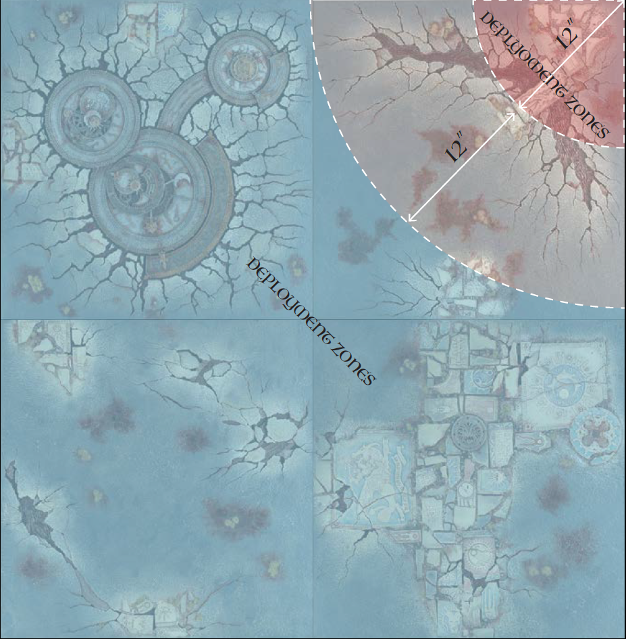

COALESCENCE 2018 BATTLEPLAN 3A:
SENSELESS RAMPAGE
Player Scoresheet
Feat | Value | You or a member of your alliance | Achieved?
Strategist | 3 | Win the battleplan
Monster Hunter | 1 | ...had a HERO without the MONSTER keyword that slayed a MONSTER
Royal Terror | 1 | ...destroyed an opponent’s unit in the Battleshock phase.
Stronger Together | 1 | ...had a BATTLELINE unit that killed a HERO.
Still only counts as one | 1 | ...destroyed an enemy unit within 3” of the attacker in the shooting phase.
WAAAAGH! | 1 | DESTRUCTION ONLY: Complete a charge in the first battleround
Long Reach of Death | 1 | DEATH ONLY: Set up a unit in your opponents deployment zone
All for One | 1 | ORDER ONLY: Do not lose any units to battleshock
Favor of the gods | 1 | CHAOS ONLY: Slay an enemy HERO with a HERO
Be there, kill square (Empower) | 1 | Have a unit on each square at the same time.
Never cared much for trees (Empower) | 1 | Have a single Hero do all 10 wounds to a single terrain feature.
Making the best of it (Banish) | 1 | End the game with the most Realmstone.
Defense in Depth (Banish) | 1 | Destroy an enemy unit in every square.

Coalescence: Desolation of Eristrat Realmstone Shards
Each piece of Baleful Realmstone also counts as a piece of Realmstone Shard for the purpose of Coalescence: Desolation of Eristrat event rules.
Number of Realmstone Shards

COALESCENCE 2018 BATTLEPLAN 3B:
CUT OFF THE HEADS

Eristrat has received your sacrifice and responds in kind. Dark omens have led you to this site, an opening in the elemental waste where rests a ruin of mythic architecture. If you are able to perform the ritual of Exaltation that your sages lay out for you, the powers of the Godbeast and the Grand Marshall of the Apocalypse combined will course through your veins. Then nothing will block your task of stamping out the vermin that still works against Eristrat in the shadows.

On your left, your ally readies their forces. You will need their strength to block the armies arrayed against you, but you would sooner die than share the power with their champion. Blades on two fronts then! To arms!

Use this battleplan if the Banish team has won the first round of battles but the Empower team has won the second round.

The armies
There are no more than 2 players per team. Each player must bring a force of no more than 750 points. All players on a team must pledge allegiance to either the Empower or the Banish faction.

COALITION OF DEATH
This battleplan uses the Coalition of Death rules, as found in the General’s Handbook 2017.

Do not use the rules for determining a Warlord as found in the Coalition of Death rules. The player who has collected the most Realmstone Shards so far in the campaign is the Warlord. If players have collected an equal amount, roll of to see who is the Warlord. At the start of the battle round which is the Warlord’s finest hour, roll to determine which effect is applied.
The Fog Of War rule on Charge Declarations will be in effect, with the following modification:

“At the beginning of each charge phase before any units charge, all players have two minutes to write down which of their units will charge in this phase. Number each unit that will charge, from first to last. They must keep their choices secret from all other players, including players on their own team. When declaring charges, each player must start with their first choice. A player may not reveal how many units are on the charge list until it is time to declare a charge and they have no more units written down.”

“This rule prevents players from coordinating, and ensures that even the best laid plans collapse when meeting the enemy!”

Do not use the chart for Divine Intervention as presented in the General’s Handbook 2017. Instead use the following chart.
Alliance | Criteria | Miraculous Effects
Banish | The team has gathered 5 or more Realmstone during this battle. | - Divine Blessings: Each Hero model heals D3 wounds. Each unit carrying Realmstone also heals D3 wounds.  - Battle Purpose: You can reroll failed save rolls.
Empower | The team has gathered 5 or more Realmstone during this game. | - Divine Curse: Each Hero model may nominate an enemy unit within 8”, that unit suffers D3 Mortal Wounds. Each unit carrying Realmstone may also nominate an enemy unit within 8”, and cause it D3 wounds. Each enemy unit may only be nominated once to be struck in this manner.  - Battle Frenzy: You can reroll charge rolls, and reroll hit and wound rolls of 1 for units that have charged in this battle round.

The battlefield
The battle is played on a 4x4 board. Set up terrain in the manner best suited to your story, or generate terrain as per the Age of Sigmar rules sheet, with the following exception: in the center of the table, place a terrain piece. This is the Site of Exaltation. No other terrain features may be placed within 6” of this feature, and the Mysterious Landscapes rules do not apply to it.

Set-Up
The teams roll a dice, rolling again in the case of a tie, and the team that rolls higher decides which two corners the Empower team will deploy in. The Banish team deploys in the opposite two corners. The territories are shown on the map below.

Place 9 tokens representing Baleful Realmstone on the table as shown in the map below. Each token will be 12” from any other token and at least 12” from a board edge.

Time of War: Desolation of Eristrat
This battleplan uses the Time of War: Desolation of Eristrat rules to describe how models may interact with Realmstone Shards. This battleplan may be played using additional Time of War rules along with Desolation of Eristrat.

Empowerment
From sites of great power, Eristrat draws its strength. A hero with sufficient strength of will can steal some of this power for themselves, and reach a dark apotheosis.
For each hero an Empower player has on the Site of Exaltation, you may roll a dice at the end of the turn. Continue to do this until your dice total for that hero reaches 8 or more. The hero is now Exalted. Immediately heal any wounds the hero has been allocated during the game. In addition, the hero heals 1 wound each hero phase, unless the unit’s warscroll states it cannot heal. In addition the unit may reroll all Hit, Wound and Save rolls of 1 for as long as it remains within the Site of Exaltation.

True champion
An Empower player may choose to target any friendly Hero models on the Site of Exaltation with any abilities, charges and attacks from their own heroes on the Empowerment site.

Victory
Do not use any victory conditions from the Warhammer Age of Sigmar rules sheet. The game lasts 5 battle rounds.

The Empower player wins a major victory if they have at least 1 Exalted hero on the Site of Exaltation at the end of the game.

The Banish team wins a major victory if all of the Empower heroes are destroyed.

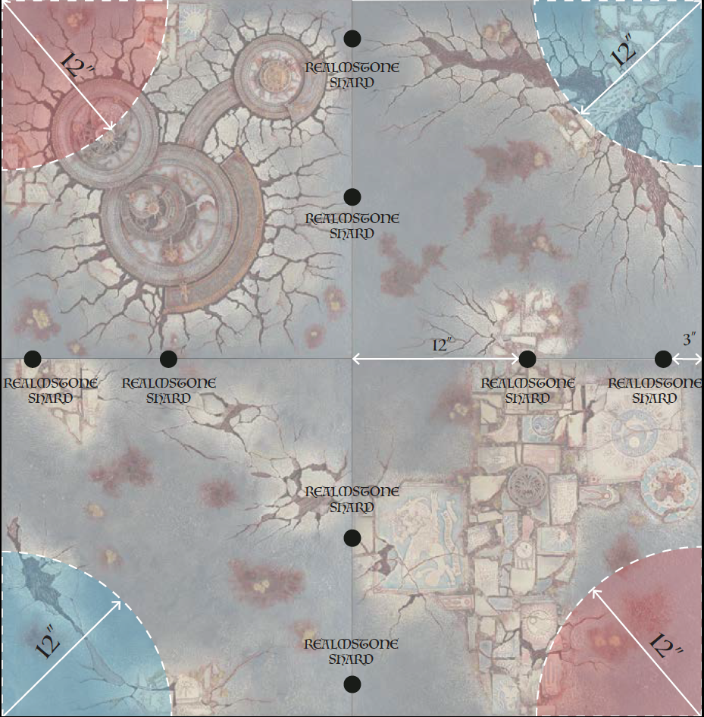

COALESCENCE 2018 BATTLEPLAN 3B:
CUT OFF THE HEADS
Player Scoresheet
Feat | Value | You or a member of your alliance | Achieved?
Strategist | 3 | Win the battleplan
Monster Hunter | 1 | ...had a HERO without the MONSTER keyword that slayed a MONSTER
Royal Terror | 1 | ...destroyed an opponent’s unit in the Battleshock phase.
Stronger Together | 1 | ...had a BATTLELINE unit that killed a HERO.
Still only counts as one | 1 | ...destroyed an enemy unit within 3” of the attacker in the shooting phase.
WAAAAGH! | 1 | DESTRUCTION ONLY: Complete a charge in the first battleround
Long Reach of Death | 1 | DEATH ONLY: Set up a unit in your opponents deployment zone
All for One | 1 | ORDER ONLY: Do not lose any units to battleshock
Favor of the gods | 1 | CHAOS ONLY: Slay an enemy HERO with a HERO
Highlander (Empower) | 1 | Destroy a friendly Hero on the Site of Exaltation with a Hero on the same site.
Cartographer (Empower) | 1 | Occupy a terrain feature in the Banish territory for two battle rounds.
There can only be one! (Banish) | 1 | Slay an empowered hero with one of your own heroes.
Circle back (Banish) | 1 | Destroy an enemy unit in their deployment zone.

Coalescence: Desolation of Eristrat Realmstone Shards
Each piece of Baleful Realmstone also counts as a piece of Realmstone Shard for the purpose of Coalescence: Desolation of Eristrat event rules.
Number of Realmstone Shards

COALESCENCE 2018 BATTLEPLAN 3C:
BREAKOUT

This could be your final chapter. After leaving your strongholds and desperately searching for a means to protect your homelands against an unstoppable force, you find yourself exhausted, miles from home, and surrounded on all sides by the hounds baying at the side of Eristrat. If you can run this final blockade you can spread crucial word: that the lands run rife with marauders and opportunists, that the realms are breaking apart under the onslaught of the godbeast, and that the Lord of the End Times is returning.

To your left is your brother in arms; once an uneasy ally and now formed by circumstance into your staunchest compatriot. When you return home, no more will your houses take up arms against each other.

If you return home, that is…

Use this battleplan if the Empower team has won the first and second rounds of battles with the most feats scored.

The armies
There are no more than 2 players per team. Each player must bring a force of no more than 750 points. All players on a team must pledge allegiance to either the Empower or the Banish faction.

COALITION OF DEATH
This battleplan uses the Coalition of Death rules, as found in the General’s Handbook 2017.

Do not use the rules for determining a Warlord as found in the Coalition of Death rules. The player who has collected the most Realmstone Shards so far in the campaign is the Warlord. If players have collected an equal amount, roll of to see who is the Warlord. At the start of the battle round which is the Warlord’s finest hour, roll to determine which effect is applied.

The Fog Of War rule on Charge Declarations will be in effect, with the following modification:

“At the beginning of each charge phase before any units charge, all players have two minutes to write down which of their units will charge in this phase. Number each unit that will charge, from first to last. They must keep their choices secret from all other players, including players on their own team. When declaring charges, each player must start with their first choice. A player may not reveal how many units are on the charge list until it is time to declare a charge and they have no more units written down.”

“This rule prevents players from coordinating, and ensures that even the best laid plans collapse when meeting the enemy!”

Do not use the chart for Divine Intervention as presented in the General’s Handbook 2017. Instead use the following chart.
Alliance | Criteria | Miraculous Effects
Banish | The team has gathered 5 or more Realmstone during this battle. | - Divine Blessings: Each Hero model heals D3 wounds. Each unit carrying Realmstone also heals D3 wounds.  - Battle Purpose: You can reroll failed save rolls.
Empower | The team has gathered 5 or more Realmstone during this game. | - Divine Curse: Each Hero model may nominate an enemy unit within 8”, that unit suffers D3 Mortal Wounds. Each unit carrying Realmstone may also nominate an enemy unit within 8”, and cause it D3 wounds. Each enemy unit may only be nominated once to be struck in this manner.  - Battle Frenzy: You can reroll charge rolls, and reroll hit and wound rolls of 1 for units that have charged in this battle round.

The battlefield
The battle is played on a 4x4 board. Set up terrain in the manner best suited to your story, or generate terrain as per the Age of Sigmar rules sheet. One side of the table, touching the blue area in the map below, is the Escape Zone.

Set-Up
The Banisher team has been defeated and surrounded, now they must break out if they wish to survive. The teams roll a dice, rolling again in the case of a tie, and the team that rolls higher decides which team will deploy the first unit. The Banish team will deploy in the red rectangle in the map below.

One Empower player will deploy in the blue rectangle in the map below. The other Empower player must set up their units in flanking positions.

Place 9 tokens representing Baleful Realmstone on the table as shown in the map below. Each token will be 12” from any other token and at least 12” from a board edge.

Time of War: Desolation of Eristrat
This battleplan uses the Time of War: Desolation of Eristrat rules to describe how models may interact with Realmstone Shards. This battleplan may be played using additional Time of War rules along with Desolation of Eristrat.

Flanking attack
Any units deployed in flanking positions may be set up in any of the Empower teams’ movement phases. If you do so, the controlling player rolls a dice. On 1-2, the unit is set up on the left table edge, on a 3-4 they are set up on the far table edge, and on 5-6 they are set up on the right table edge. All models must be wholly within 3” of the edge and more than 6” from enemy models. If deploying the unit is impossible, reroll the dice to see which edge they appear on. This counts as their move for that movement phase.

Escape
Any Banish units that end a battle round within 6” of the Escape Zone table edge and more than 3” from enemy models escape the battlefield. Remove the units from the table (they are not considered slain). Only models that were set up during deployment may escape in this manner.

Turns
The game lasts for 5 battle rounds.

Victory
Do not use any victory conditions from the Warhammer Age of Sigmar rules sheet. The game lasts 5 battle rounds.

If the Banish players escape with 3 or more units, they win a major victory.

If the Banish players escape with 1 unit, the game is a draw.

If the Banish player fail to escape with any units, the Empower players wins a major victory.

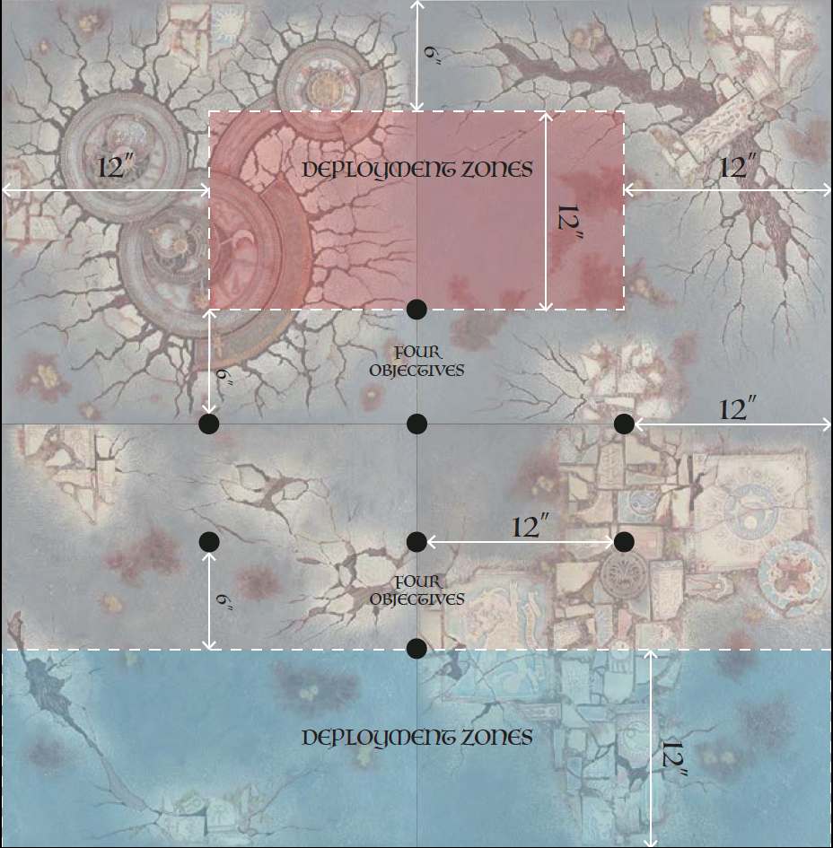

COALESCENCE 2018 BATTLEPLAN 3C:
BREAKOUT
Player Scoresheet

Feat | Value | You or a member of your alliance | Achieved?
Strategist | 3 | Win the battleplan
Monster Hunter | 1 | ...had a HERO without the MONSTER keyword that slayed a MONSTER
Royal Terror | 1 | ...destroyed an opponent’s unit in the Battleshock phase.
Stronger Together | 1 | ...had a BATTLELINE unit that killed a HERO.
Still only counts as one | 1 | ...destroyed an enemy unit within 3” of the attacker in the shooting phase.
WAAAAGH! | 1 | DESTRUCTION ONLY: Complete a charge in the first battleround
Long Reach of Death | 1 | DEATH ONLY: Set up a unit in your opponents deployment zone
All for One | 1 | ORDER ONLY: Do not lose any units to battleshock
Favor of the gods | 1 | CHAOS ONLY: Slay an enemy HERO with a HERO
Sideways priorities (Banish) | 1 | Destroy two enemy units that were deployed in a flanking attack.
Heroic Challenge (Banish) | 1 | After deployment, but before rolling to see who gets the first turn, nominate 3 units and escape with at least 1 of them.
Don’t even want to be here (Empower) | 1 | A unit deployed in a flanking attack on the far edge comes within 12” of the escape edge.
End of the road (Empower) | 1 | Destroy an enemy unit that is within 6” of the Escape Zone.

Coalescence: Desolation of Eristrat Realmstone Shards
Each piece of Baleful Realmstone also counts as a piece of Realmstone Shard for the purpose of Coalescence: Desolation of Eristrat event rules.
Number of Realmstone Shards
COALESCENCE 2018 BATTLEPLAN 3D:
FALTERING LOYALTY

With Empower’s failures, Archaon’s wrath seems certain. Some of Empower’s armies are wavering in their conviction. On the opposite side, some of Banish’ armies see that only they can turn the tide. Archaon’s rewards would be endless for a traitor who secured him victory.

Use this battleplan if the Empower team has won the first round of battles but the Banish team has won the second rounds of battles with the most feats scored for the team.

The armies
There are no more than 2 players per team. Each player must bring a force of no more than 750 points. All players on a team must pledge allegiance to either the Empower or the Banish faction.

COALITION OF DEATH
This battleplan uses the Coalition of Death rules, as found in the General’s Handbook 2017.

Do not use the rules for determining a Warlord as found in the Coalition of Death rules. The player who has collected the most Realmstone Shards so far in the campaign is the Warlord. If players have collected an equal amount, roll of to see who is the Warlord. At the start of the battle round which is the Warlord’s finest hour, roll to determine which effect is applied.

The Fog Of War rule on Charge Declarations will be in effect, with the following modification:

“At the beginning of each charge phase before any units charge, all players have two minutes to write down which of their units will charge in this phase. Number each unit that will charge, from first to last. They must keep their choices secret from all other players, including players on their own team. When declaring charges, each player must start with their first choice. A player may not reveal how many units are on the charge list until it is time to declare a charge and they have no more units written down.”

“This rule prevents players from coordinating, and ensures that even the best laid plans collapse when meeting the enemy!”

Do not use the chart for Divine Intervention as presented in the General’s Handbook 2017. Instead use the following chart.

Alliance | Criteria | Miraculous Effects
Banish | The team has gathered 5 or more Realmstone during this battle. | - Divine Blessings: Each Hero model heals D3 wounds. Each unit carrying Realmstone also heals D3 wounds.  - Battle Purpose: You can reroll failed save rolls.
Empower | The team has gathered 5 or more Realmstone during this game. | - Divine Curse: Each Hero model may nominate an enemy unit within 8”, that unit suffers D3 Mortal Wounds. Each unit carrying Realmstone may also nominate an enemy unit within 8”, and cause it D3 wounds. Each enemy unit may only be nominated once to be struck in this manner.  - Battle Frenzy: You can reroll charge rolls, and reroll hit and wound rolls of 1 for units that have charged in this battle round.

The battlefield
The battle is played on a 4x4 board. Set up terrain in the manner best suited to your story, or generate terrain as per the Age of Sigmar rules sheet.

Set-Up
The teams roll a dice, rolling again in the case of a tie, and the team that rolls higher decides which corner the Empowered team will deploy in. The territories are shown on the map below.

Place 9 tokens representing Baleful Realmstone on the table as shown in the map below. Each token will be 12” from any other token and at least 12” from a board edge.

Time of War: Desolation of Eristrat
This battleplan uses the Time of War: Desolation of Eristrat rules to describe how models may interact with Realmstone Shards. This battleplan may be played using additional Time of War rules along with Desolation of Eristrat.

Treachery and Triumph
Once per battle, one player on each team may switch sides. At the start of the second battle round, each player must secretly place a dice with a number of their choosing up. Once all players have decided, reveal the dice. Players who have chosen 1-3 have decided to stay with their team, players who have chosen 4-6 have chosen to switch. If both players on a team decide to stay, they gain 6 Realmstone Shard pieces. If a player on a team decides to switch, that player gains 4 Realmstone Shard pieces and the staying player gains none. If both players decide to switch, neither player gets any additional Realmstone Shard pieces. These additional Realmstone Shard pieces are not represented in the game outside of scoring purposes and are never carried by models or dropped upon defeat of a model.

Once loyalists and betrayers are decided, balance the teams. First, determine the realmstone total for each player by adding the realmstone gained from any loyal/betrayal bonuses to the number of shards currently controlled by the player's models.

Next, all betrayers will switch loyalties, with their models immediately becoming friendly to all former enemy models and enemies to all former friendly models.

Finally, if any three players are loyal to one another, determine the player with the smallest realmstone total. This player changes loyalty to the other side, resulting in two loyalties with two players apiece.

Victory
Do not use any victory conditions from the Warhammer Age of Sigmar rules sheet. The game lasts 5 battle rounds. The side possessing the most Realmstone Shards at the end of five rounds wins a major victory.

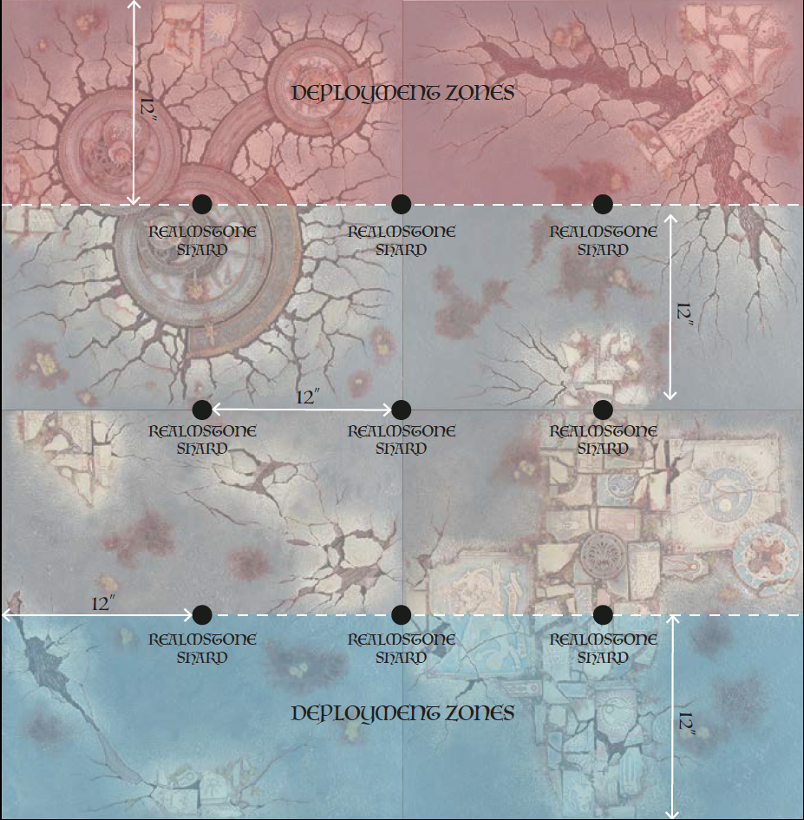

COALESCENCE 2018 BATTLEPLAN 3A:
FALTERING LOYALTY
Player Scoresheet

Feat | Value | You or a member of your alliance | Achieved?
Strategist | 3 | Win the battleplan
Monster Hunter | 1 | ...had a HERO without the MONSTER keyword that slayed a MONSTER
Royal Terror | 1 | ...destroyed an opponent’s unit in the Battleshock phase.
Stronger Together | 1 | ...had a BATTLELINE unit that killed a HERO.
Still only counts as one | 1 | ...destroyed an enemy unit within 3” of the attacker in the shooting phase.
WAAAAGH! | 1 | DESTRUCTION ONLY: Complete a charge in the first battleround
Long Reach of Death | 1 | DEATH ONLY: Set up a unit in your opponents deployment zone
All for One | 1 | ORDER ONLY: Do not lose any units to battleshock
Favor of the gods | 1 | CHAOS ONLY: Slay an enemy HERO with a HERO
Surrounded by traitors | 1 | Be the only player that chooses to remain Loyal.
Untrustworthy | 1 | Be the only player that chooses to become a Betrayer.
Finish the Fight (Banish) | 1 | Your team slays both enemy generals
Never give up, never surrender (Empower) | 1 | Take a token by slaying an enemy unit holding it.

Coalescence: Desolation of Eristrat Realmstone Shards
Each piece of Baleful Realmstone also counts as a piece of Realmstone Shard for the purpose of Coalescence: Desolation of Eristrat event rules.
Number of Realmstone Shards

TIME OF WAR RULES
No matter which of the Mortal Realms you set your games, the story of Coalescence: Desolation of Eristrat is set in a world besieged by godlike forces, where reality itself is breaking apart. To help bring this feeling to your games, consider using any of the following Time of War rules, after the first.

Time of war: Desolation of Eristrat

This Time of War rules sheet is meant to be used with the Desolation of Eristrat event pack. It is designed to function alongside other Time of War rules, such as those provided in the pack or others the NEO may choose to use.

During when Eristrat awoke, great chunks of Realmstone Shards resonated with it. Now empowered, these shards may give their masters the ability to banish or empower the realmbeast.

Realmstone Shards
All battleplans in the Coalescence: Desolation of Eristrat event have Realmstone shard tokens or markers on the board, or ways for units to gain such shards during the game. These are represented by tokens. See each specific battleplan for how this works.
Carriers of the Realmstone Shards
At the end of your movement phase, any of your units within 1” of a Realmstone Shard token and more than 3” from enemy units may pick up the Realmstone Shard. Remove the token from the table, it is now held by the unit which picked it up. Realmstone Shards are always held by the whole unit, rather than individual models within the unit. It may be useful to place the tokens next to the unit to represent how many it carries.

If a unit carrying Realmstone Shards is slain, place a number of tokens equal to the Realmstone held by the unit where the last model in the unit stood. This may now be picked up again. If a unit carrying Realmstone Shard is slain in the combat phase, the unit which caused the fatal wound receives the Realmstone the model was carrying.

Realmstone Shards in the Event
The Coalescence: Desolation of Eristrat event contains multiple battles where one can gather shards. These carry over from game to game. Each player must keep track of how many Realmstone Shards they earn each game. If Shards are awarded to a team, divide the shards as evenly as possible, rolling off for any odd numbers.

At the start of game 2 and 3 of the event, each player must divide their existing Realmstone Shard pieces into their army. Your general must have at least one Shard, but you may otherwise choose freely. Split shards after deployment is over, but before rolling for the first turn. Only models deployed on the table may begin the games with shards in this manner. Note that this requires your army’s general to be deployed on the table.

Realmstone Shards given to units in this manner many be lost, taken, and picked up as described under Carriers of the Realmstone Shards.

Realmstone Shards given to units in this manner do count towards any victory conditions, but not towards Feats or the Divine Intervention rules in game 3.

Time of War: Penumbral Reaches

The Deep Shadows
All ranges for abilities, attacks and spells are reduced to 18”. Those abilities, spells or attacks with a range of 18” or less are reduced to ranged 12”.

Ensorcelled Mists
The mists from Ulgu lead travelers astray, but battle will always find you… At the start of each battleround, before rolling for priority, roll a dice for each unit that is more than 6” from any other units. On a 1-2, that unit is lost in the mists. The controlling player must nominate a point more than 9” from any units. The enemy play may then set up the unit anywhere within 8” of that point, wholly outside of 9” from any other models.

Mysterious Terrain
Do not use the Mysterious Landscape scenery table as described in the Age of Sigmar rules sheet. Instead, when rolling for Mysterious Landscapes, on a 1-2 the terrain is Mystical, on a 3-4 the terrain is Sinister, and on a 5-6 the terrain is Arcane.

Time of War: Ferric Moors

Metal Shift
When rolling on the Mysterious Terrain chart, replace the Deadly result with the following: Metal Shift: If a unit within 3” of this terrain feature is targeting a unit within 3” of this terrain feature in the combat phase, the defender uses the attacker’s Save roll instead of its own.

Transmogrifying Terrain
Just as in the realm of Chamon, the land here shifts and changes as it pleases. At the start of each battle round, before rolling for priority, roll on the Mysterious Landscape chart for each terrain piece that has at least 1 unit within 3” of it. This new result immediately replaces the previous result.

Time of War: Somatic Plains

A Mind of Its Own
At the start of each battle round, before rolling for priority, each terrain feature on the board will move. Players take turns nominating terrain features, starting with the player who had the previous turn. Each player nominates a terrain feature and a direction, then rolls a D6 to see how far it travels, before the next player may nominate a feature. Continue doing this until each terrain feature has been moved. Any models wholly within each terrain feature will move with it. If there are any models on the feature, but not wholly within, or who are in the path of a moving terrain feature, the unit suffers D3 Mortal Wounds as they are crushed or pushed aside by the feature. Models who cannot be fit on a feature that moved towards them move the minimum distance necessary to make room for the feature. Moving terrain may break unit coherency.

Never Quite Dead
At the start of the battleshock phase, before tests have been taken, roll a dice for each model that has been slain that turn. On a 6, the unit which the slain model belongs to heals a wound. This may resurrect fallen models, first by healing any wounds allocated to the unit previously in the battle, then resurrecting a single model with a single wound remaining. If more sixes were rolled, you may heal the newly resurrected model to its starting wounds characteristic, then resurrect another, until you have used all your sixes. This cannot be done for units that were wholly destroyed. Any models resurrected in this manner no longer count towards battleshock.

LOCATION:

EMPOWER WINS!

LOCATION:

BANISH WINS!

